REV. | Description |  |  |  |  |  | Date
S00 | SPEC ISSUE |  |  |  |  |  | 10/27/2017
S01 | 102A-17B155  ADD ADP-160FR AAD |  |  |  |  |  | 11/30/2017
S02 | 102A-17C074  ADD ADP-160FR AA |  |  |  |  |  | 12/29/2017
S03 | 102A-183090  ADD ADP-160FR AB |  |  |  |  |  | 03/30/2018
S04 | 102A-184092  ADD ADP-160FR ABA |  |  |  |  |  | 04/26/2018
00 | 102A-191045  Release mass production spec. |  |  |  |  |  | 01/11/2019
01 | 102A-219168  ADD ADP-160FR ASA/ASB |  |  |  |  |  | 10/05/2021
 |  |  | 台達電子工業股份有限公司  DELTA ELECTRONICS, INC. |  |  | DESCRIPTION :  電氣規格 (Electrical Specification)
THESE DRAWINGS AND SPECIFICATIONS ARE THE PROPERTY OF DELTA  ELECTRONICS, INC. AND SHALL NOT BE REPRODUCED OR USED AS THE  BASIS FOR THE MANUFACTURE OR SELL OF APPARATUSES OR DEVICES  WITHOUT PERMISSION. |  |  |  |  |  | MODEL NO. :  ADP-160FR SERIES
Date |  | Drawn |  | Design (EE) | Design (ME) | DOCUMENT NAME. :  ES-160FR SERIES |  | REV.
10/05/2021 |  | 邱美淳 |  | 王竹君 | 李昱緯 |  |  | 01
File Name:DF-PSLA4V-2R01.DOC SHEET 2 OF 21
MODEL LIST: ADP-160FR AAA/AAB/AAC/AAD/AA/AB/ABA/ASA/ASB
1. Scope

This specification applies to the switching regulator used for Class II type products.
2. Specification

Refer to the following
3. Appearance

Other way indicate
4. Safety specifications

USA, Canada : UL60950-1+C-UL (R/C認証) 2nd Edition

EU : IEC/EN 60950-1 (CB) 1st Edition/2nd Edition

KC mark

5. EMC
EMC | Item | Specifications and Test Conditions
EMI | Conduction  (雜音端子電壓) | VCCI-B, FCC Part15 B  IT: EN55022, EN55024, CISPR22, CISPR24  AV: EN55013, EN55020, CISPR13, CISPR20
EMI | Radiation  (不要輻射) | VCCI-B, FCC Part15 B  IT: EN55022, EN55024, CISPR22, CISPR24  AV: EN55013, EN55020, CISPR13, CISPR20
EMI | Harmonic  (電源高調坡) | IT: EN61000-3-2  AV: EN61000-3-2
EMI | Flicker  (電源閃爍) | IT: EN61000-3-3  AV: EN61000-3-3
EMS | Electrostatic Discharge  (靜電氣放電) | IEC61000-4-2  Test Probe: 150pF / 330 ohm  Air : ~ +/- 8kV  Contact : ~ +/-6kV  No function error, no latch off, no damage.
EMS | RS  (放射無線周波數磁界) | IEC61000-4-3  3V/m  AM modulation  1kHz 80%  80~10000MHz  Sweep rate: 1.5x10-3 decade/s  No function error, no latch off, no damage.
EMS | EFT/B  (快速暫態雜訊) | IEC61000-4-4  1KV  No function error, no latch off, no damage.
EMS | Surge  (雷擊) | IEC61000-4-5  Common : +/-4KV  Normal : +/-2KV  Phase + : 0ºC, 90ºC  Phase - : 180ºC, 270ºC  No function error, no latch off, no damage.
EMS | CS  (傳導性妨害) | EC61000-4-6  3V  AM modulation  1kHz 80％  0.15～80MHz  Sweep rate:1.5x10-3 decade/s  No function error, no latch off, no damage.
EMS | Immunity  (電源周波數磁界) | IEC61000-4-8  1A/m  x,y,z direction  No function error, no latch off, no damage.
EMS | AC dip  (電源電壓變動) | IEC61000-4-11  Above 95%, reduction,0.5 cycle No function error, no latch off, no damage.  (240Vac→12Vac) & (100Vac→5Vac) (Performance Criterion B)  30% reduction, 25 cycle  (240Vac → 168Vac) & (100Vac→ 70Vac) After the test, AC OFF then ON , then unit  should be able to start again and no function  error, no latch, no damage. (Performance  Criterion C)  Above 95%, reduction,250 cycle  (240Vac→ 12Vac)&(100Vac→5Vac) After thet test, AC OFF then ON , then unit should be able to start again and no function error, no latch off, no damage.(Performance Criterion C).

6. Input characteristics
 | Item | Condition |  | Specification
1 | Rated input voltage | - |  | 100 ~ 240 Vac
2 | Input voltage range | - |  | 85 ~ 276 Vac
3 | Input current | 5VSB/1.5A, 12V/13A @ 100Vac |  | <2.5A
4 | Rated input frequency | - |  | 50Hz / 60Hz
5 | Input frequency | - |  | 47 ~ 63 Hz
6 | Input inrush current | 85 ~ 276 Vac  Rated load  (Test with  3KV AC  source). | Ta= 25ºC  Cold start | Less than 140A
6 | Input inrush current | 85 ~ 276 Vac  Rated load  (Test with  3KV AC  source). | Ta= 40ºC  Repeat AC ON<=>OFF  (5VSB: 120mA load, 12V OFF) | Less than 180A/2msec 以下
7. Output characteristics
7-1. Output System:
Control signal (input): 12V on/off by ACDC_STBY
Control signal (output): ACIN_DET indicate the AC in or not, and inform about the status of abnormal condition.
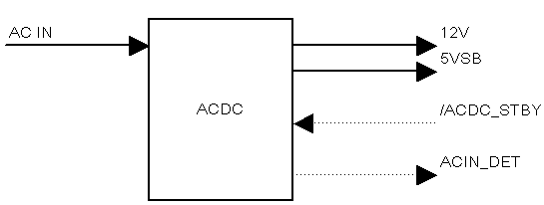
7-2 Output Characteristics:
Below output capacitance (smallest capacity) should be satisfied
12V : 22uF (Ceramic capacitor)
5VSB : 10uF (Ceramic capacitor)
Output | Output Voltage |  | Output Current |  |  | Ripple & Nioise (at rated load)
Output | Rated | Tolerance | Peak | Rated | Min. | Ta= -5~40ºC
5VSB | 4.8V | +/- 4% | 3A | 1.5A | 0A | 50mVp-p,max
12V | 12V | + 5%,- 4% | 19.5A/30msec | 13A | 0A | 150mVp-p,max

Output | OCP | OVP
5VSB | 3 ~ 3.75A | 6V,max
12V | 19.5 ~ 24.375A | 15.6V,max
7-3 Other characteristics:
 | Item | Condition and Specification
1 | No load operating | Input range: 85 ~ 276 Vac  No function error, no damage, and output voltage should be within regulation.
2 | Over / Undershoot | Input range: 85 ~ 276 Vac  Output voltage should be within 10% of rated output voltage.
3 | Start with capacitive load | Input range: 85 ~ 276 Vac  Output should be in parallel with below capacitor :  12V : 4700uF  5VSB : 100uF  The unit should be able to start stably.
4 | Protective function | OCP |  | Once the 5VSB has been detected abnormal (5VSB OC/OV), all output should be shut down  Once the 12V has been detected abnormal (12V OC/OV/OT/UV), 12V output should be shut down immediately, and pull ACIN_DET to low.
4 | Protective function | OVP
4 | Protective function | OTP
4 | Protective function | Protection functional operation  (Signal and power output)
5 | Recovery from protection | Remove latch function after the AC OFF and within 3 minutes.
6 | Transient response | 5VSB | Input range: 85 ~ 276 Vac  [ 5VSB load change ]  Change range : 100%~60%, 90%~50%, 80%~40%  Change frequency : 10Hz & 1kHz.  Change rate : 0.01A/usec  12V load : 0A and 13A |  | Output voltage should be requlated within 4.8V +/-4%.
6 | Transient response | 12V | Input range: 85 ~ 276 Vac  [ 12V load change ]  Change range : 100%~80%, 90%~70%, 80%~60%  Change frequency : 10Hz & 1kHz.  Change rate : 0.3A/use  5V load : 0A and 1.5A |  | Output voltage should be requlated within 12V +5% -4%.

8. Control terminal characteristics
ACDC_STBY | Signal polarity  【 ACDC_STBY signal level 】  Vin_max : 3.465V  Vih : Min 2.2V  Vil : Max 0.6V  Iin_max : 0.15mA
   | ACDC_STBY
   | Hi | Low
  5VSB | ON | ON
  12V | ON | OFF
ACIN_DET | 【 ACIN_DET signal level 】  With the signal output which fills up below-mentioned Spec, on ACDC side the P-D resistant internal of 100kΩ.  [ AC ON ]  ACIN_DET : Voh: Min=4.5V, Max=5.1V  [ AC OFF ]  ACIN_DET : Vol: Min=0V, Max=0.3V

9. Power ON/OFF (Sequential control & Timing)
Item |  |  |  | Condition |  | Specification
5VSB turn on time  (t_5vsb_on) |  |  |  | ACDC_STBY: Low |  | 5VSB output voltage should be regulated to 4.8V+/-4% within 300mS.
ACIN_DET turn on delay time  (t_acin_det_delay) |  |  |  | AC input: OFF to ON |  | ACIN_DET: Low to Hi  Turn on after 5VSB output has stabilized.
ACIN_DET turn on delay time 2  (t_acin_det_delay2) |  |  |  | AC input: ON to OFF then ON again. |  | Once ACIN_DET from Hi to Low, and if turn Hi again, it should be wait for 10ms or more.
ACIN_DET turn off delay time (t_ac_off) |  |  |  | 5VSB : no load  ACDC_STBY: Low |  | more than 40msec
 |  |  |  | ACDC_STBY: Hi |  | ACIN_DET should be turn low while 12V output drop between 12V to 0V.
12V turn on time  (t_main_on) |  |  |  | ACDC_STBY on to 12V rise time. |  | 12V output voltage can be regulated to 12V+/-5%  within 400mS.
12V turn on rise time  (t_main_on_2) |  |  |  | 10V to 12V rise time. |  | 12V output voltage from 10V rise to 12V within 150msec.
12V turn on rise time  (t_main_on_3) |  |  |  | 0V to 12V rise time |  | 12V output voltage from 0V rise to 12V within 2~20msec.
12V turn off time  (t_main_off) |  |  |  | 5VSB: rated load  12V : 8A load  ACDC_STBY: Hi to Low |  | 12V output voltage from 100%(avg voltage before change state) drop to 10% within 250mS.
Line cycle dropout  (t_dur1) |  |  |  | Refer to item 10-7.
Hold up time(t_dur2)
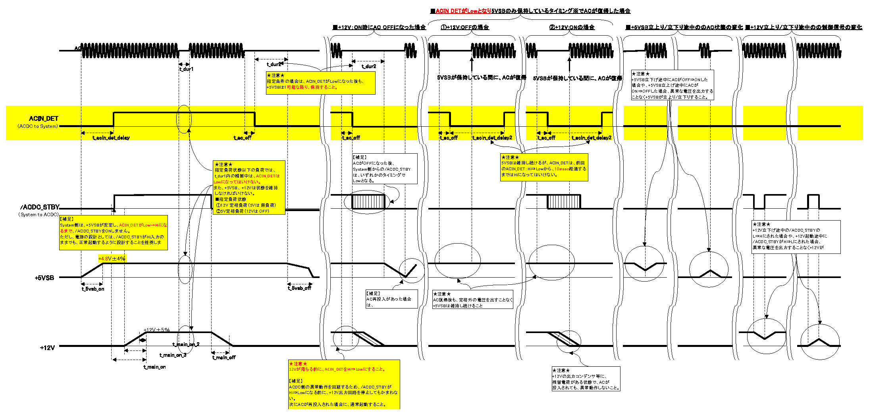

10. Common specifications
 | Item |  |  |  | Condition |  | Specification
1 | Switching frequency |  |  |  | 100Vac input.  Rated load. |  | -
2 | Power factor |  |  |  | - |  | IEC61000-3-2.
3 | Life |  |  |  | Rated input voltage.  Ambient temperature, constant humidity. |  | 70,000Hr or more with thermal test BOX.  => 20,000Hr, 12V/5VSB rated load  (FAN cooling).  => 50,000Hr, 12V OFF/5VSB rated load  (air convection).
4 | Efficiency | 5VSB  (12V OFF) |  |  | Rated input voltage, load (0.03A) |  | 55.5%
4 | Efficiency |  |  |  | Rated input voltage, load (0.05A) |  | 63.0%
4 | Efficiency |  |  |  | Rated input voltage, load (0.06A) |  | 66.5%
4 | Efficiency |  |  |  | Rated input voltage, load (0.1A) |  | 71.5%
4 | Efficiency |  |  |  | Rated input voltage, load (0.3A) |  | 78%
4 | Efficiency |  |  |  | Rated input voltage, load (0.37A) |  | 78%
4 | Efficiency |  |  |  | Rated input voltage, load (0.6A). |  | 79.5%
4 | Efficiency |  |  |  | Rated input voltage, load (0.75A). |  | 80.0%
4 | Efficiency |  |  |  | Rated input voltage, load (1A) |  | 80.5%
4 | Efficiency |  |  |  | Rated input voltage, load (1.5A) |  | 80%
4 | Efficiency | 12V  (5VSB: 0A) |  |  | Rated input voltage, load (0.2A). |  | 52%
4 | Efficiency |  |  |  | Rated input voltage, load (0.3A). |  | 60.0%
4 | Efficiency |  |  |  | Rated input voltage, load (1A). |  | 75.0%
4 | Efficiency |  |  |  | Rated input voltage, load (2A). |  | 84.0%
4 | Efficiency |  |  |  | Rated input voltage, load (3A). |  | 87.5%
4 | Efficiency |  |  |  | Rated input voltage, load (4A). |  | 89.0%
4 | Efficiency |  |  |  | Rated input voltage, load (5A). |  | 89.5%
4 | Efficiency |  |  |  | Rated input voltage, load (6A). |  | 90.0%
4 | Efficiency |  |  |  | Rated input voltage, load (7A). |  | 90.5%
4 | Efficiency |  |  |  | Rated input voltage, load (8A). |  | 90.0%
4 | Efficiency |  |  |  | Rated input voltage, load (9A). |  | 90.0%
4 | Efficiency |  |  |  | Rated input voltage, load (11A). |  | 89.5%
4 | Efficiency |  |  |  | Rated input voltage, load (13A). |  | 89.0%
5 | Idle power consumption |  |  |  | Rated input voltage  12V OFF  5VSB: 0A load |  | 0.085W(max)
5 |  |  |  |  | Rated input voltage  12V 0A load  5VSB: 0A load |  | 0.9~1.7W
6 | Internal components temperature rise |  |  |  | Rated input voltage.  Thermal test BOX.  Ta=40ºC |  | There is enough de-rating of temperature for all component.  No component over derating before OTP trigger.
7 | Line cycle dropout  (瞬停保証時間) |  | t_dur1 |  | Rated input voltage  - 12V: 6.5A (5VSB 0A) |  | 50Hz 2 cycle(=40ms).  Output voltage shall be satisfy electric characteristic.
7 |  |  | t_dur2 |  | Input voltage range  1. 5VSB: 1.5A load  2. 12V: OFF & ON |  | 5VSB shall be low after ACIN_DET low
8 | 入力片切test |  |  |  | AC ON→ Line OPEN→Line SHORT.  AC ON→Neutral OPEN→Neutral SHORT. |  | Same as AC ON→ AC OFF→ AC ON  Same as AC ON→ AC OFF→ AC ON
9 | Leakage current |  |  |  | Rated input voltage. |  | 100uArms or less.
10 | AC input discharge time |  |  |  | Input 121V or less, from AC power OFF to 37% rated. |  | 1 sec or less.
10 |  |  |  |  | Input 122V or more, from AC power OFF to 45V. |  | 1 sec or less.
11 | 400V input protection |  |  |  | 400Vac input / 2sec. |  | No safety hazard.
12 | Dielectric strength |  |  |  | Input between primary and secondary.  QA (sampling) : 3.0kVac 50/60Hz 60sec  Production line (all): 3.1kVac 50/60Hz 3sec |  | IEC60950-1 item 5.2  Sense current : 10mA or less.  Without damage to parts.
13 | Insulation resistance |  |  |  | 500 Vdc input between primary and secondary. |  | 10 Mohm or more.
14 | Insulation distance |  |  |  | - |  | Should be met the safety requirement and add external 0.5mm for SIE request.

11. Environmental
 | Item | Condition & Specification
1 | Operation guarantee temperature range | -5 ~ +40ºC  (humidity 20~90% Rh)
2 | Storage guarantee temperature range | -35 ~ +80ºC  (humidity 10~90% Rh)
3 | High temperature / high humidity operation | +40ºC/90% Rh  1000Hr operation.  Electric characteristic shall be satisfied.
4 | High temperature / high humidity storage | After put the unit with max. storage temperature & humidity in storage 96Hr, then change the condition to ambient temperature & humidity 1Hr, and then test it.  Electric characteristic shall be satisfied.
5 | Low temperature storage | After put the unit with min. storage temperature in storage 96Hr, then change the condition to ambient temperature 1Hr, and then test it.  Electric characteristic shall be satisfied.
6 | Low temperature operation | After put the unit with min. operation temperature in storage 5Hr, then test it.  Electric characteristic shall be satisfied.
7 | Low temperature starting | Rated input voltage±10%.  Rated load.  Electric characteristic shall be satisfied.  Testing follow below temperature curve:  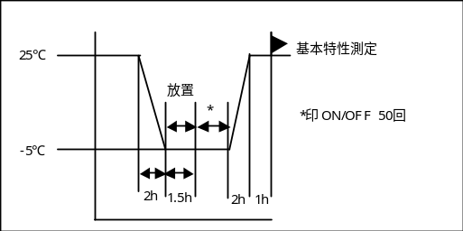
8 | Damp heat | Temperature: 40±2℃  Humidity 90~95%  Store: 48 hour  It wipes the water-drop, 30 minutes leaves in normal temperature normal moisture, dielectric strength and Insulation resistance shall be satisfied.
9 | Thermal shock | -20℃: 4 hours  80℃: 4 hours  -20℃~80℃: 10℃/minute  It designates this as 1 cycles and 5 cycles leaves, electric characteristic shall be satisfied and without distinct damage in appearance.
10 | Heat cycle | Put the unit with temperature / humidity (follow below temperature / humidity curve) in storage, and then test it with rated input voltage / rated load.  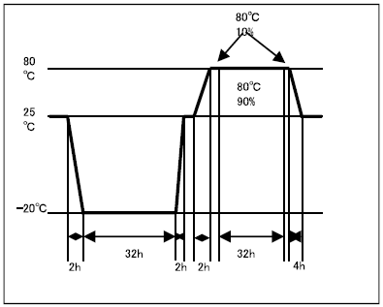  Electric characteristic shall be satisfied and without distinct damage in appearance.

12. Other
 | Item | Condition & Specification
1 | Appearance | There is no adhesion of the foreign material and the dirty fingerprint. In addition, when producing it depends on the oil and the like which is used, there is no stench of the product.
2 | Adhesive | Chloroprene is designated as the main component, do not use the adhesive.
3 | Weight | NA
4 | Noise | -

13. 耐久性能
 | Item | Condition & Specification
1 | Load open / short | 5VSB  Rated input voltage.  After output short 1sec, AC off (disable latch mode) then re-start as 1cycle, this 100 cycles after doing electric characteristic shall be satisfied.  (將輸出端子Short 一秒後, AC OFF (Latch解除) 再切入AC 以此為lcycle, 實行100 cycle後,  滿足電器特性。 )
1 | Load open / short | 12V  Rated input voltage.  After output short 1sec, AC off (disable latch mode) then re-start as 1cycle, this 100 cycles after doing electric characteristic shall be satisfied.  (將輸出端子Short 一秒後, AC OFF (Latch解除) 再切入AC 以此為lcycle, 實行100 cycle後,  滿足電器特性 。)
2 | Power ON/OFF  (Primary) | Rated input voltage +/-10%.  12V: OFF  5VSB: rated load (resistor load)  Air convection | The primary power supply ON/OFF shall be done 100,000 times.  (5sec/ON, 5sec/OFF)  Electric characteristic shall be satisfied.
2 | Power ON/OFF  (Secondary) | Rated input voltage +/-10%.  5VSB: Rated load (resistor load)  12V: Rated load (resistor)  Inside thermal test BOX,FAN cooling | The secondary ACDC_STBY control the ON/OFF shall be done 100,000 times.  (5sec/ON, 5sec/OFF)  Electric characteristic shall be satisfied.
3 | O/S test | Input voltage : 90V & 264V  Output load : Rated load.  Open & Short parts:  Transistor and IC: Combination between all terminals  Diode: Between A-K  Transformer & chock: Coil  Capacitance: Between terminals  When AC input turn on state, to do components open/short test. | No ignition or smoke or damage.
4 | Electrostatic Discharge | IEC61000-4-2  Rated input voltage.  Rated load.  Test probe: 150pF / 330 ohm.  Each 5 times.  Discharge location:  [Air]  . Any surface hand can touch except the air intake vent.  [Indirect]  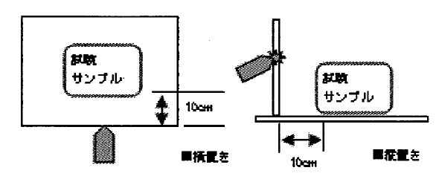  [Contact]  . Any metal hand can touch.  . power & signal (input/output). | Air :  +/- 12KV: no function error.  +/- 14KV: no latch off, no damage.  +/- 15KV: no quality accident.
4 | Electrostatic Discharge |  | Indirect :  +/- 8KV: no function error,  no latch off, no damage.  +/- 15KV: no quality accident.
4 | Electrostatic Discharge |  | Contact :  +/- 12KV: no function error,  no latch off, no damage.  +/- 15KV: no quality accident.
5 | AC Transient | Rated input voltage, rated load.  Charge capacitor: 2000pF.  Surge voltage: 7~15kV.  3 times/each. | +/-10kV: no function error.  +/-15kV: no latch off, no damage.
6 | AC noise | Rated input voltage, rated load.  Pulse width: 100ns/1000ns.  Noise voltage: +/-1kV. | No function error, no latch off, no damage.
7 | Surge  雷擊 | Rated input voltage, rated load.  IEC1000-4-5 with CR box (13 ohm + 9uF)  Phase +: 0º, 90º.  Phase -: 180º, 270º.  Each 5 times.  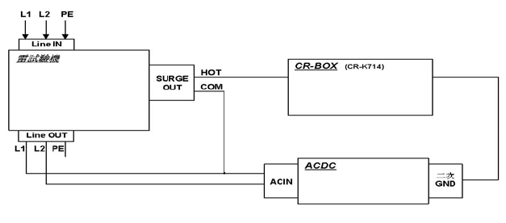 | L-N/N-L  +/- 6k: no function error, no latch off,  no damage.  +/- 8V: cam damage, no quality accident.  L-G/N-G  +/- 6k: no function error, no latch off,  no damage.  +/- 8V: cam damage, no quality accident.
8 | Vibration | Frequency (7~30~7Hz / 5 minutes),  Acceleration 23.5 m/s²  X,Y,Z each 20 minutes (Non-operating/Random).  Electric characteristic shall be satisfied.  There shall be no blistering damage to the construction.
9 | Shock | 1.Non-operating/half-sine  Three axis (X,Y,Z direction) shall be  applied in both directions of mutually  perpendicular axis 1 times (a total of 6  times) for table a.  Sample : 2pcs  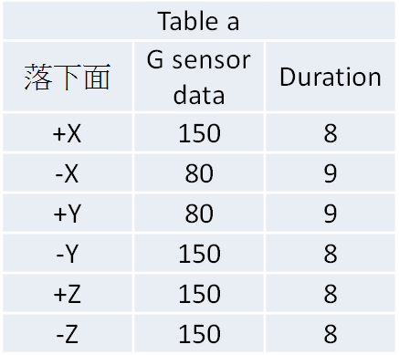  2.Non-operating/half-sine  A directions for a sample,  G & Duration value follow table b  Total sample : 12pcs  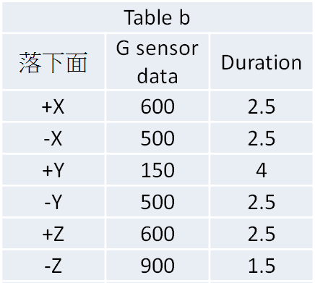  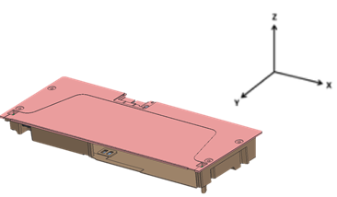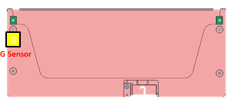
10 | CMZE | Follow test program by customer provide.  Vin:100Vac/50Hz, 230Vac/50Hz  Vo:5VSB/0A,12V/6.3A & 5VSB/0A,12V/0.2A  Spec:<-6dBm@100kHz~500kHz

14. MECHANICAL
Item |  | Judgement | Condition
1 | Vibration | Electric characteristic shall be satisfied. And no remarkable abnormal occurrence on the appearance and construction. Parts and assembly with customer system must also be satisfied. | Non-operating/Random:  The entire frequency range from 7Hz(0.822 g² /Hz) to 30Hz(0.192 g² /Hz) and return to 7Hz(0.822 g² /Hz) shall be a transverse in 5 min. Three axis (X,Y,Z direction) shall be applied 20minutes acceleration: 23.5 m/s² (2.85Grms)
2 | Shock | Electric characteristic shall be satisfied. And no remarkable abnormal occurrence on the appearance and construction. Parts and assembly with customer system must also be satisfied. | 1.Non-operating/half-sine  Three axis (X,Y,Z direction) shall be  applied in both directions of mutually  perpendicular axis 1 times (a total of 6  times) for table a.  Sample : 2pcs  2.Non-operating/half-sine  A directions for a sample,  G & Duration value follow table b  Total sample : 12pcs  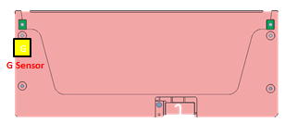
3 | Drop I | 1. No component broken..  2. No PWB copper pad peeling and broken  3. Hi-pot test pass with specific condition. ( AC 3300V/1min )  4. No soldering crack.  6. ATS function Pass. | 測試前,Case 請用螺絲鎖附在系統配合孔固定case  1.Drop TIMES: 5 times for every surface (six side),total 30 times  2. Test surface material : The concrete  3.Drop height: 10cm.
4 | Drop II | 1. No component broken..  2. No PWB copper pad peeling and broken  3. Hi-pot test pass with specific condition. ( AC 3300V/1min )  4. No soldering crack. .  5. ATS function Pass. | 測試前,Case 請用螺絲鎖附在系統配合孔固定case  1.Drop TIMES: 1 times for every surface (six side),total 6 times  2. Test surface material : The concrete  3.Drop height: 45cm.

5. Packing test :
5.1 Drop test condition:
<1>.Drop height:80.0CM
<2>.Impact surface: concrete floor
<3>.Drop times: 1 side (Bottom side),total 10 times
Criteria:
The sample has no electric characteristic issue and without
distinct damage in appearance.
5.2 Vibration test condition:
<1>.Wave: Random
<2>.Acceleration: 1.146Grms
<3>.Frequency: 5-200Hz
<4>.Duration:30min/side
<5>.Orientations: each axis total 3 times
Criteria:
The sample has no electric characteristic issue and without distinct damage in appearance.

15. For safety
15.1 Atiltude : 2000m
15.2 Thermal test setup
fan 1= 12V ,
fan 2= 12V,
fan 3= 8V
Thermal test ambient : 40deg C
Setup method
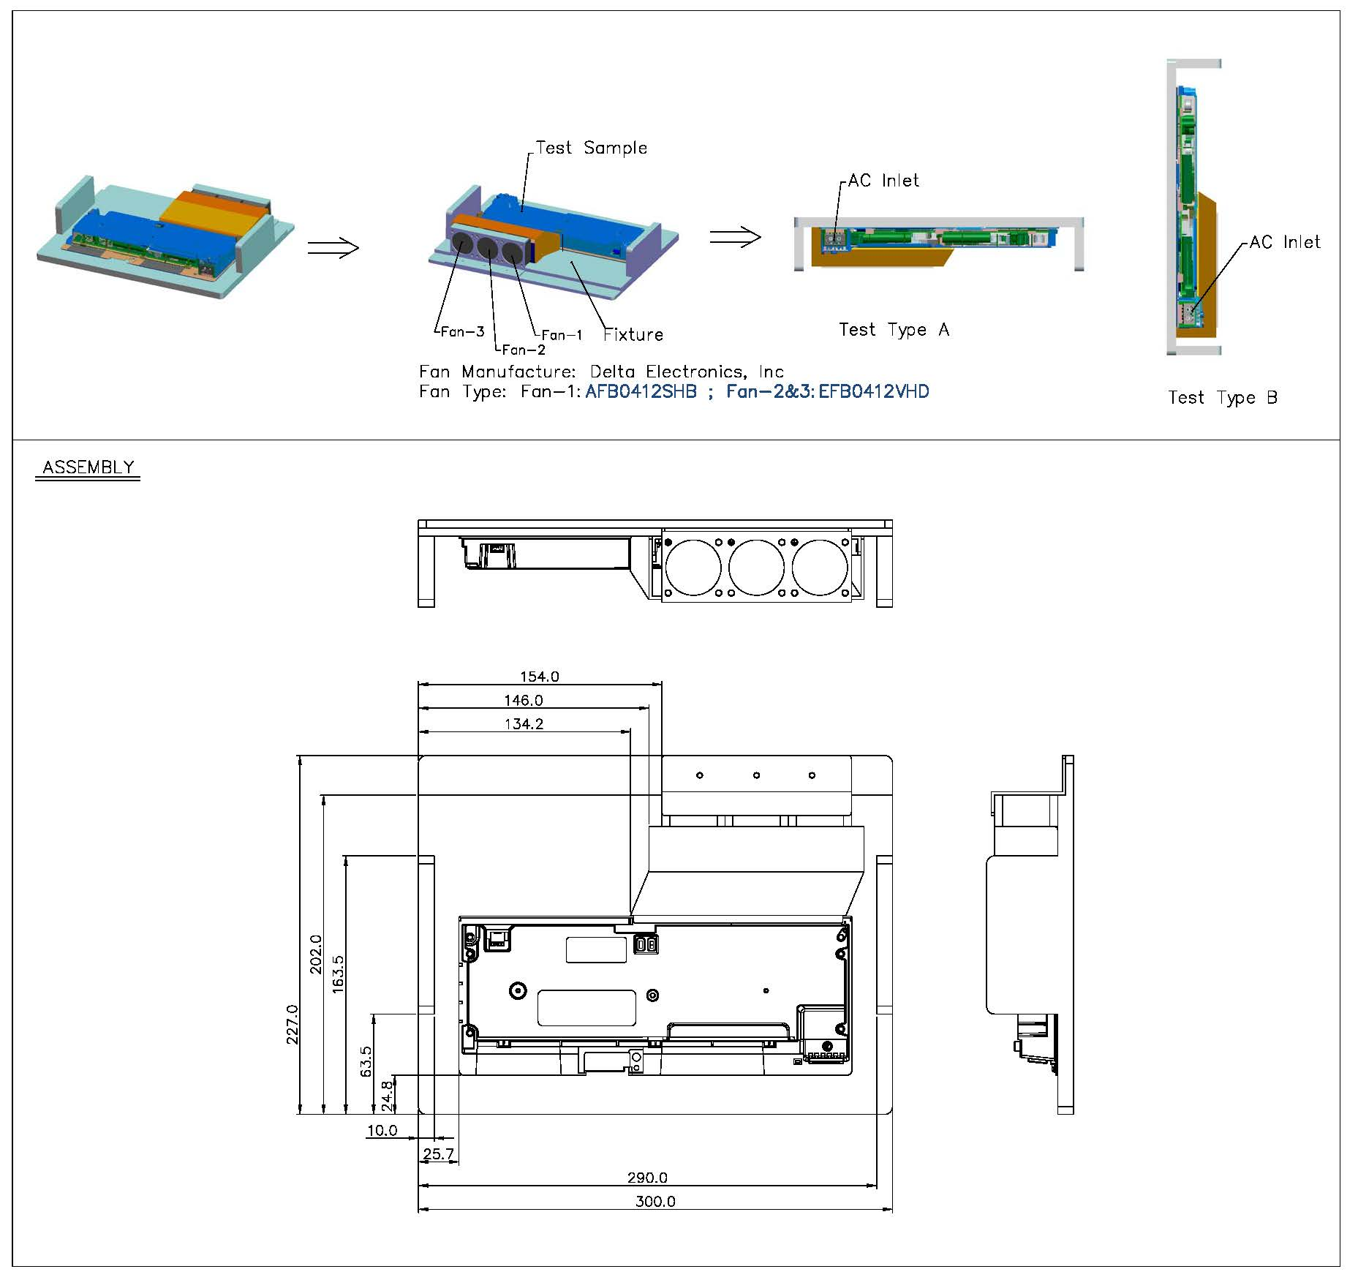

16. 噪音測試量測 (帶 case 測試), 麥克風距離case 出風口 5cm , 依照客戶指定負載如下,
(1) 5VSB:量測 0.03A , 0.33A, 12V OFF.
12V:量測 0.33A, 5V 0A.
(2) 此機種 case 有開孔, 定義為 open frame 機種:
階段 | EVT | DVT&PVT | M/P FQC | M/P QE
測試距離 | 5cm | 5cm | 5cm | 5cm
輸入電壓 | 100V & 230V | 100V & 230V | 100V & 230V | 100V & 230V
標準 | 40 dB max.

17. Product Ingress protection(IP) rating: Not requirement

Product Application: Game Consoles

